Six and Stones
Instructor: Stephen Senter
Team
Victor Olatunji, Tinotenda Chibi, Mofunoluwato Oyeyemi, Kulraj Singh, Gurinder Singh
Lake Ridge Community Hospital Database Management System
Database Development 1 INFT 2106

Contents
INTRODUCTION 2
MISSION STATEMENT 3
DATA DIAGRAMS 3
Venn Diagram 3
Data flow diagram 4
FUNCTIONAL & NON-FUNCTIONAL REQUIREMENTS 4
Functional Requirements 4
Patient Management 4
Staff Records 5
Hospital Records 5
Access & Roles 6
Physician Management 6
Financial & Transaction Management 7
Operational Reporting 7
System Integration & Data Consistency 8
Non-Functional Requirements 8
3NF RELATIONAL SCHEMA 9
Entities Not in 3rd Normal Form 10
Reasons for Not Using 3rd Normal Form 10
Examples 11
ENTITY RELATIONSHIPS DIAGRAM 11
DATA DICTIONARY 12
SQL CREATE SCRIPTS 18
SQL INSERT STATEMENTS 25
SQL QUERIES (Select statements with snapshots) 28

INTRODUCTION
The Lake Ridge Community Hospital (LRCH) requires a reliable and organized system to manage the large amount of information generated through daily operations. Patient admissions, room assignments, staff activities, diagnostic procedures, and billing processes all produce data that must be stored accurately and accessed quickly. Without a proper database system, these activities can become slow, inconsistent, and difficult to track across departments.
This project presents a database solution designed to centralize hospital information and support smooth operational workflows. The system brings together patients, staff, rooms, items, physicians, bookings, and financial records in one structured environment. By organizing these connections clearly and ensuring data integrity, the LRCH database helps improve service delivery, reduce errors, and provide the foundation for more efficient hospital management.

MISSION STATEMENT
The mission of the LRCH database system is to replace the current disconnected and paper-based processes with one reliable and integrated platform that supports accurate patient information, faster workflows, and consistent data across all departments. The system will store and manage key activities such as patient admissions, physician assignments, treatments, room usage, billing, and revenue records in a secure and organized way. The goal is to improve efficiency, reduce delays, and support clear communication between medical and administrative staff. By giving everyone real-time and accurate information, the system will help LRCH deliver better patient care, make informed decisions, and meet the hospital's growing operational needs.

DATA DIAGRAMS

Venn Diagram

Data flow diagram

FUNCTIONAL & NON-FUNCTIONAL REQUIREMENTS

Functional Requirements

Patient Management
- The system shall allow medical staff to record and report the results of laboratory tests and procedures.
- The system shall allow medical staff to assign, store, and retrieve treatment prescriptions as part of a patient’s record.
- The system shall support immediate system-wide access for patient registration and billing inquiries.
- The system will allow retrieval of patient records by patient number or by patient name and phone number.
- The system will update the patient's location and admission details upon re-admission.
- The system will maintain a history of patient locations across visits to support contact-tracing.
- The system shall track patient financial status, including secondary financial sources (e.g., insurance provider).
- The system shall archive patient records three years after the last discharge if the patient has not been readmitted.

Staff Records
- The system will allow authorized users to create staff records, including staff ID, name, role, department, contact information, and login credentials.
- The system shall allow retrieval of staff records by staff ID, name, or department.
- The system shall allow authorized users to update staff records (e.g., role changes, contact details, department transfers).
- The system shall allow authorized users to delete staff records when a staff member leaves the hospital, ensuring archival of historical data for audit purposes.

Hospital Records
- The system shall allow authorized users to create hospital records, including hospital ID, name, address, contact information, and capacity (e.g., number of beds).
- The system shall allow retrieval of hospital records by hospital ID, name, or location (e.g., city, region).
- The system shall allow authorized users to update hospital records (e.g., bed capacity changes, contact details, services offered).
- The system will allow authorized users to delete hospital records when a hospital is closed or merged, ensuring archival of historical data for reporting.

Access & Roles
- The system shall require staff authentication (username/password, role-based login).
- The system shall support role-based access control, ensuring staff can only perform operations permitted by their role (e.g., physicians vs. clerks vs. administrators).
- The system shall log all staff activities (e.g., patient record updates, billing entries) for accountability and auditing.
- The system shall allow administrators to assign and modify staff roles and permissions.

Physician Management
- The system shall maintain physician records, including physician numbers, name, specialty, and contact information.
- The system shall generate a daily physician report listing patients currently admitted who were referred to by that physician.

Financial & Transaction Management
- The system shall accumulate costs by department and cost center.
- The system shall ensure that each item is associated with one and only one cost center.
- The system shall ensure that each item has a fixed charge applicable to all patients.
- The system shall determine the financial source for each transaction from the patient record.
- The system shall generate a daily revenue report listing all revenue-generating transactions, sorted by patient.
- The system shall generate a weekly revenue analysis report showing total revenues by cost center and distribution by method of payment.
- The system shall generate patient bill statements containing patient details, cost centers, charges, and balance due.

Operational Reporting
- The system shall generate a daily room utilization report showing hospital room occupancy and accommodation type.
- The system will track room/bed availability in real time for admissions staff

System Integration & Data Consistency
- The system shall ensure that all operational modules (patient management, physician management, billing, accounting, reporting) are integrated and share a common database.

Non-Functional Requirements
- The system shall maintain 98% uptime annually.
- The system shall support expansion from 100 to 200 beds without major redesign.
- The system shall enforce role-based access control and encrypt patient data in transit and at rest.
- The system shall provide an intuitive interface for clerks with minimal training required.
- The system shall be accessible via web browsers and mobile devices.
- The system shall allow administrators to update cost centre definitions without downtime.
- The system shall exchange patient billing data with provincial health systems using HL7 standards.
- The system shall recover from failures within 5 minutes using automated backup procedures.

3NF RELATIONAL SCHEMA
Patient(patient_id, patient_name, patient_address, patient_email, patient_number)
Hospital(hospital_id, hospital_name, hospital_address, hospital_telnumber)
Bed(bed_id, bed_type, bed_name)
Room(room_id, room_type, room_name)
Space(space_id, hospital_id, room_id, bed_id)
Staff(staff_id, staff_name, staff_address, staff_email, staff_number, role, department_id)
Department(department_id, department_name, department_desc)
Cost_centre(cost_centre_id, department_id, cost_centre_name)
Physician(physician_id, physician_name, address, phone_number, email, specialty)
Item(item_code, item_name, item_desc, item_type, cost_centre, charge_amount, space_id, charge_type)
Booking(booking_id, patient_id, space_id, cost_centre_id, staff_id, item_code, begin_date, end_date, fin_source, physician_id)
Revenue(revenue_id, patient_id, booking_id, balance_due, item_code)
History(hist_id, patient_id, space_id, cost_centre_id, staff_id, item_code, begin_date, end_date, fin_source, physician_id)
Invoice(invoice_id, patient_id, date)
Line(line_id, invoice_id, revenue_id, start_date, end_date)
Results(result_id, booking_id, patient_id, status, results)

Entities Not in 3rd Normal Form
Some entities such as booking, revenue, history, result, and item are intentionally designed not to fully comply with 3rd Normal Form (3NF). This design choice is made to optimize faster loading times while still maintaining accurate data.

Reasons for Not Using 3rd Normal Form
- Performance Optimization: Denormalizing certain entities reduces the number of joins required during queries, which can significantly improve read performance and loading times.
- Data Accuracy: Although denormalized, these entities are structured carefully to avoid data anomalies and maintain consistency.

Examples
- Booking: Combines patient, space, staff, item, and physician references in one table to quickly retrieve all booking-related information without multiple joins.
- Revenue: Includes patient and booking references along with balance information to facilitate fast revenue reporting.
- History: Stores historical booking-like data for audit or reporting purposes, denormalized for efficient retrieval.
- Result: Contains booking and patient references with status and results data for quick access to outcome information.
- Item: Holds charge and cost details along with location references to speed up billing and inventory queries.
This approach balances the trade-off between normalization and performance, ensuring the system remains responsive while preserving data integrity.

ENTITY RELATIONSHIPS DIAGRAM
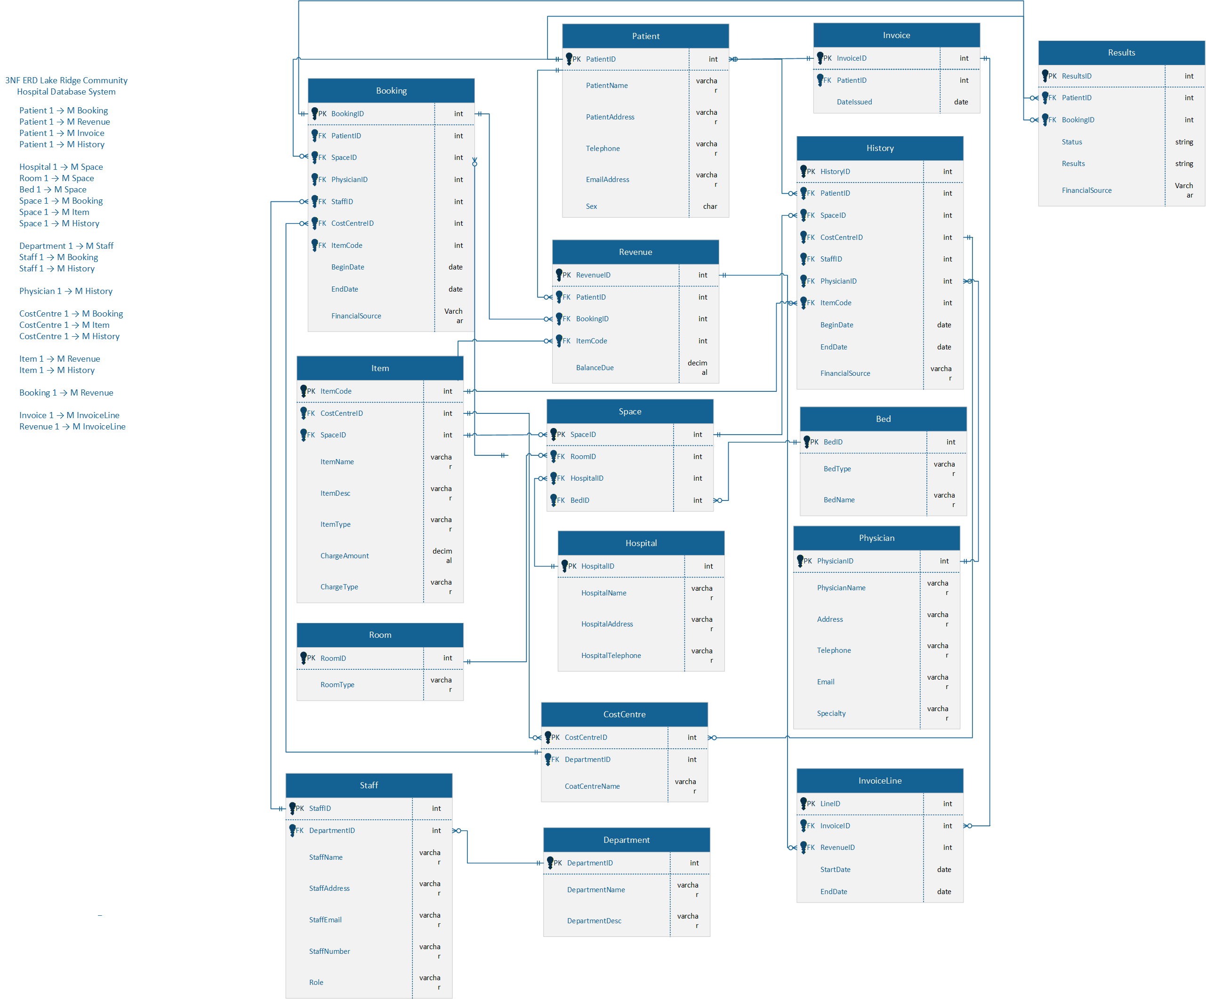

DATA DICTIONARY

Entity | Field | Description | Type | Key/Relation
patient | patient_id | Unique identifier for each patient | integer | PK
 | patient_name | Full legal name | string
 | patient_address | Residential address | string
 | patient_email | Contact email | string
 | patient_number | Phone number | string
hospital | hospital_id | Unique identifier for hospital | integer | PK
 | hospital_name | Official name | string
 | hospital_address | Physical location | string
 | hospital_telnumber | Main telephone number | string
bed | bed_id | Unique identifier for bed | integer | PK
 | bed_type | Classification (ICU, general, etc.) | string
 | bed_name | Label or code | string
room | room_id | Unique identifier for room | integer | PK
 | room_type | Classification (ward, private, ICU) | string
 | room_name | Room Lable | string
space | space_id | Unique identifier for space | integer | PK
 | hospital_id | Linked hospital | integer | FK → hospital
 | room_id | Linked room | integer | FK → room
 | bed_id | Linked bed | integer | FK → bed
staff | staff_id | Unique identifier for staff | integer | PK
 | staff_name | Full name | string
 | staff_address | Residential address | string
 | staff_email | Contact email | string
 | staff_number | Phone number | string
 | role | Job role (nurse, admin, etc.) | string
 | department_id | Linked department | integer | FK → department
department | department_id | Unique identifier for department | integer | PK
 | department_name | Name of department | string
 | department_desc | Description | string
cost_centre | cost_centre_id | Unique identifier for cost centre | integer | PK
 | department_id | Linked department | integer | FK → department
 | cost_centre_name | Name of cost centre | string
physician | physician_id | Unique identifier for physician | integer | PK
 | physician_name | Full name | string
 | address | Residential/practice address | string
 | phone_number | Contact number | string
 | email | Contact email | string
 | specialty | Medical specialty | string
item | item_code | Unique identifier for item/service | string | PK
 | item_name | Name of item/service | string
 | item_desc | Description | string
 | item_type | Category (medication, procedure, etc.) | string
 | cost_centre | Linked cost centre | integer | FK → cost_centre
 | charge_amount | Monetary charge | decimal
 | space_id | Linked space | integer | FK → space
 | charge_type | Type of charge (per hour, per unit) | string
booking | booking_id | Unique identifier for booking | integer | PK
 | patient_id | Linked patient | integer | FK → patient
 | space_id | Linked space | integer | FK → space
 | cost_centre_id | Linked cost centre | integer | FK → cost_centre
 | staff_id | Linked staff | integer | FK → staff
 | item_code | Linked item | string | FK → item
 | begin_date | Start date/time | datetime
 | end_date | End date/time | datetime
 | fin_source | Financial source (insurance, self-pay) | string
 | physician_id | Linked physician | integer | FK → physician
revenue | revenue_id | Unique identifier for revenue record | integer | PK
 | patient_id | Linked patient | integer | FK → patient
 | booking_id | Linked booking | integer | FK → booking
 | balance_due | Outstanding balance | decimal
 | item_code | Linked item | string | FK → item
history | hist_id | Unique identifier for patient history | integer | PK
 | patient_id | Linked patient | integer | FK → patient
 | space_id | Linked space | integer | FK → space
 | cost_centre_id | Linked cost centre | integer | FK → cost_centre
 | staff_id | Linked staff | integer | FK → staff
 | item_code | Linked item | string | FK → item
 | begin_date | Start date/time | datetime
 | end_date | End date/time | datetime
 | fin_source | Financial source | string
 | physician_id | Linked physician | integer | FK → physician
invoice | invoice_id | Unique identifier for invoice | integer | PK
 | patient_id | Linked patient | integer | FK → patient
 | date | Invoice date | date
line | line_id | Unique identifier for invoice line | integer | PK
 | invoice_id | Linked invoice | integer | FK → invoice
 | revenue_id | Linked revenue | integer | FK → revenue
 | start_date | Start date/time | datetime
 | end_date | End date/time | datetime
result | result_id | Unique identifier for test result | integer | PK
 | booking_id | Linked booking | integer | FK → booking
 | patient_id | Linked patient | integer | FK → patient
 | status | Status of test (pending, completed) | string
 | results | Outcome or findings | text

SQL CREATE SCRIPTS
-- ============================================================= -- CREATE TABLE STATEMENTS FOR LAKE RIDGE COMMUNITY HOSPITAL -- DATABASE MANAGEMENT SYSTEM (LRCH DBMS) -- =============================================================
CREATE DATABASE LakeRidgeCommunityHospitalDB; GO USE LakeRidgeCommunityHospitalDB; GO
/* ============================================================= HOSPITAL TABLE Stores basic information about each hospital location. ============================================================= */ DROP TABLE IF EXISTS Hospital; CREATE TABLE Hospital ( HospitalID INT IDENTITY(1,1) PRIMARY KEY, HospitalName VARCHAR(150) NOT NULL, HospitalAddress VARCHAR(255), HospitalTelephone VARCHAR(25) ); -- DISPLAY SELECT * FROM Hospital;
/* ============================================================= ROOM TABLE Contains all room types used in the hospital. ============================================================= */ DROP TABLE IF EXISTS Room; CREATE TABLE Room ( RoomID INT IDENTITY(1,1) PRIMARY KEY, RoomType VARCHAR(50) NOT NULL ); -- DISPLAY SELECT * FROM Room;
/* ============================================================= BED TABLE Holds details about beds found inside hospital rooms. ============================================================= */ DROP TABLE IF EXISTS Bed; CREATE TABLE Bed ( BedID INT IDENTITY(1,1) PRIMARY KEY, BedType VARCHAR(50), BedName VARCHAR(50) ); -- DISPLAY SELECT * FROM Bed;
/* ============================================================= SPACE TABLE Links each hospital to its room and specific bed. Represents a physical space where patients can be placed. ============================================================= */ DROP TABLE IF EXISTS Space; CREATE TABLE Space ( SpaceID INT IDENTITY(1,1) PRIMARY KEY, HospitalID INT NOT NULL, RoomID INT NOT NULL, BedID INT NULL ); -- DISPLAY SELECT * FROM Space;
/* ============================================================= DEPARTMENT TABLE Stores all departments within the hospital. ============================================================= */ DROP TABLE IF EXISTS Department; CREATE TABLE Department ( DepartmentID INT IDENTITY(1,1) PRIMARY KEY, DepartmentName VARCHAR(100) NOT NULL, DepartmentDesc VARCHAR(255) );
-- DISPLAY SELECT * FROM Department;
/* ============================================================= STAFF TABLE Stores information about all hospital staff members. Includes optional link to a department. ============================================================= */ DROP TABLE IF EXISTS Staff; CREATE TABLE Staff ( StaffID INT IDENTITY(1,1) PRIMARY KEY, StaffName VARCHAR(150) NOT NULL, StaffAddress VARCHAR(255), StaffEmail VARCHAR(150), StaffNumber VARCHAR(25), Role VARCHAR(100), DepartmentID INT NULL );
-- DISPLAY SELECT * FROM Staff;
/* ============================================================= COST CENTRE TABLE Tracks financial and operational cost centres. ============================================================= */ DROP TABLE IF EXISTS CostCentre; CREATE TABLE CostCentre ( CostCentreID INT IDENTITY(1,1) PRIMARY KEY, CostCentreName VARCHAR(150), Address VARCHAR(255), DepartmentID INT NULL ); -- DISPLAY SELECT * FROM CostCentre;
/* ============================================================= PATIENT TABLE Stores demographic and contact information about patients. ============================================================= */ DROP TABLE IF EXISTS Patient; CREATE TABLE Patient ( PatientID INT IDENTITY(1,1) PRIMARY KEY, PatientName VARCHAR(150) NOT NULL, PatientAddress VARCHAR(255), Telephone VARCHAR(25), EmailAddress VARCHAR(150), Sex CHAR(1) );
-- DISPLAY SELECT * FROM Patient;
/* ============================================================= PHYSICIAN TABLE Contains physician information and specialties. ============================================================= */ DROP TABLE IF EXISTS Physician; CREATE TABLE Physician ( PhysicianID INT IDENTITY(1,1) PRIMARY KEY, PhysicianName VARCHAR(150) NOT NULL, Specialty VARCHAR(100), Telephone VARCHAR(25), Email VARCHAR(150) );
-- DISPLAY SELECT * FROM Physician;
/* ============================================================= ITEM TABLE Stores billable items such as tests, medications, and services. Includes links to cost centres and physical spaces. ============================================================= */ DROP TABLE IF EXISTS Item; CREATE TABLE Item ( ItemCode INT IDENTITY(1,1) PRIMARY KEY, CostCentreID INT NULL, SpaceID INT NULL, ItemName VARCHAR(150), ItemDesc VARCHAR(255), ItemType VARCHAR(50), ChargeAmount DECIMAL(10,2), ChargeType VARCHAR(50) );
-- DISPLAY SELECT * FROM Item;
/* ============================================================= BOOKING TABLE Records patient admissions or usage of a space. Tracks start and end times for each booking. ============================================================= */ DROP TABLE IF EXISTS Booking; CREATE TABLE Booking ( BookingID INT IDENTITY(1,1) PRIMARY KEY, PatientID INT NOT NULL, SpaceID INT NOT NULL, CostCentreID INT NULL, StaffID INT NULL, BookingStart DATETIME, BookingEnd DATETIME );
-- DISPLAY SELECT * FROM Booking;
/* ============================================================= REVENUE TABLE Stores financial charges generated from items and bookings. ============================================================= */ DROP TABLE IF EXISTS Revenue; CREATE TABLE Revenue ( RevenueID INT IDENTITY(1,1) PRIMARY KEY, PatientID INT NOT NULL, BookingID INT NULL, ItemCode INT NULL, BalanceDue DECIMAL(10,2) DEFAULT 0.00, FinancialSource VARCHAR(100), ChargeAmount DECIMAL(10,2) DEFAULT 0.00, RevenueDate DATETIME DEFAULT GETDATE(), PhysicianID INT NULL );
-- DISPLAY SELECT * FROM Revenue;
/* ============================================================= INVOICE TABLE Generates invoices for patients with summary contact details. ============================================================= */ DROP TABLE IF EXISTS Invoice; CREATE TABLE Invoice ( InvoiceID INT IDENTITY(1,1) PRIMARY KEY, PatientID INT NOT NULL, DateIssued DATETIME NOT NULL DEFAULT GETDATE(), Telephone VARCHAR(25), EmailAddress VARCHAR(150) );
-- DISPLAY SELECT * FROM Invoice;
/* ============================================================= INVOICE LINE TABLE Holds detailed billing lines linked to revenue entries. ============================================================= */ DROP TABLE IF EXISTS InvoiceLine; CREATE TABLE InvoiceLine ( LineID INT IDENTITY(1,1) PRIMARY KEY, InvoiceID INT NOT NULL, RevenueID INT NOT NULL, LineQty INT DEFAULT 1, LineAmount DECIMAL(10,2) NOT NULL );
-- DISPLAY SELECT * FROM InvoiceLine;
/* ============================================================= HISTORY TABLE Logs all patient actions, treatments, staff involvement, item usage, and linked revenue. Acts as the audit trail. ============================================================= */ DROP TABLE IF EXISTS History; CREATE TABLE History ( HistoryID INT IDENTITY(1,1) PRIMARY KEY, PatientID INT NOT NULL, SpaceID INT NULL, CostCentreID INT NULL, StaffID INT NULL, ItemCode INT NULL, FinancialSource VARCHAR(100), PhysicianID INT NULL, RevenueID INT NULL, StartDate DATETIME, EndDate DATETIME, Notes VARCHAR(400) );
-- DISPLAY SELECT * FROM History;
/* ============================================================= RESULT TABLE Stores outcomes or results linked to bookings. ============================================================= */ DROP TABLE IF EXISTS Result; CREATE TABLE Result ( ResultID INT IDENTITY(1,1) PRIMARY KEY, PatientID INT NOT NULL, BookingID INT NOT NULL, Status VARCHAR(150), Result VARCHAR(150) );
-- DISPLAY SELECT * FROM Result;
-- ============================================================= -- FOREIGN KEY CONSTRAINTS -- (All constraints are written out fully and clearly explained) -- =============================================================
/* SPACE foreign keys */ ALTER TABLE Space ADD CONSTRAINT FK_Space_Hospital FOREIGN KEY (HospitalID) REFERENCES Hospital(HospitalID);
ALTER TABLE Space ADD CONSTRAINT FK_Space_Room FOREIGN KEY (RoomID) REFERENCES Room(RoomID);
ALTER TABLE Space ADD CONSTRAINT FK_Space_Bed FOREIGN KEY (BedID) REFERENCES Bed(BedID);
/* STAFF foreign key */ ALTER TABLE Staff ADD CONSTRAINT FK_Staff_Department FOREIGN KEY (DepartmentID) REFERENCES Department(DepartmentID);
/* COST CENTRE foreign key */ ALTER TABLE CostCentre ADD CONSTRAINT FK_CostCentre_Department FOREIGN KEY (DepartmentID) REFERENCES Department(DepartmentID);
/* ITEM foreign keys */ ALTER TABLE Item ADD CONSTRAINT FK_Item_CostCentre FOREIGN KEY (CostCentreID) REFERENCES CostCentre(CostCentreID);
ALTER TABLE Item ADD CONSTRAINT FK_Item_Space FOREIGN KEY (SpaceID) REFERENCES Space(SpaceID);
/* BOOKING foreign keys */ ALTER TABLE Booking ADD CONSTRAINT FK_Booking_Patient FOREIGN KEY (PatientID) REFERENCES Patient(PatientID);
ALTER TABLE Booking ADD CONSTRAINT FK_Booking_Space FOREIGN KEY (SpaceID) REFERENCES Space(SpaceID);
ALTER TABLE Booking ADD CONSTRAINT FK_Booking_CostCentre FOREIGN KEY (CostCentreID) REFERENCES CostCentre(CostCentreID);
ALTER TABLE Booking ADD CONSTRAINT FK_Booking_Staff FOREIGN KEY (StaffID) REFERENCES Staff(StaffID);
/* REVENUE foreign keys */ ALTER TABLE Revenue ADD CONSTRAINT FK_Revenue_Patient FOREIGN KEY (PatientID) REFERENCES Patient(PatientID);
ALTER TABLE Revenue ADD CONSTRAINT FK_Revenue_Booking FOREIGN KEY (BookingID) REFERENCES Booking(BookingID);
ALTER TABLE Revenue ADD CONSTRAINT FK_Revenue_Item FOREIGN KEY (ItemCode) REFERENCES Item(ItemCode);
ALTER TABLE Revenue ADD CONSTRAINT FK_Revenue_Physician FOREIGN KEY (PhysicianID) REFERENCES Physician(PhysicianID);
/* INVOICE foreign key */ ALTER TABLE Invoice ADD CONSTRAINT FK_Invoice_Patient FOREIGN KEY (PatientID) REFERENCES Patient(PatientID);
/* INVOICE LINE foreign keys */ ALTER TABLE InvoiceLine ADD CONSTRAINT FK_InvoiceLine_Invoice FOREIGN KEY (InvoiceID) REFERENCES Invoice(InvoiceID);
ALTER TABLE InvoiceLine ADD CONSTRAINT FK_InvoiceLine_Revenue FOREIGN KEY (RevenueID) REFERENCES Revenue(RevenueID);
/* HISTORY foreign keys */ ALTER TABLE History ADD CONSTRAINT FK_History_Patient FOREIGN KEY (PatientID) REFERENCES Patient(PatientID);
ALTER TABLE History ADD CONSTRAINT FK_History_Space FOREIGN KEY (SpaceID) REFERENCES Space(SpaceID);
ALTER TABLE History ADD CONSTRAINT FK_History_CostCentre FOREIGN KEY (CostCentreID) REFERENCES CostCentre(CostCentreID);
ALTER TABLE History ADD CONSTRAINT FK_History_Staff FOREIGN KEY (StaffID) REFERENCES Staff(StaffID);
ALTER TABLE History ADD CONSTRAINT FK_History_Item FOREIGN KEY (ItemCode) REFERENCES Item(ItemCode);
ALTER TABLE History ADD CONSTRAINT FK_History_Physician FOREIGN KEY (PhysicianID) REFERENCES Physician(PhysicianID);
ALTER TABLE History ADD CONSTRAINT FK_History_Revenue FOREIGN KEY (RevenueID) REFERENCES Revenue(RevenueID);
/* RESULT foreign keys */ ALTER TABLE Result ADD CONSTRAINT FK_Result_Patient FOREIGN KEY (PatientID) REFERENCES Patient(PatientID);
ALTER TABLE Result ADD CONSTRAINT FK_Result_Booking FOREIGN KEY (BookingID) REFERENCES Booking(BookingID);

SQL INSERT STATEMENTS
-- Insert Statements to populate designated tables in the database
USE LakeRidgeCommunityHospitalDB GO -- HOSPITALS INSERT INTO Hospital (HospitalName, HospitalAddress, HospitalTelephone) VALUES ('Lake Ridge Community Hospital', '100 Main St, Oshawa, ON', '905-111-0001'), ('Central Health Clinic', '200 King St, Oshawa, ON', '905-222-0002'), ('Northside Medical', '350 College Ave, Oshawa, ON', '905-333-0003');
-- ROOMS INSERT INTO Room (RoomType) VALUES ('Private'), ('SemiPrivate'), ('ICU'), ('Ward3'), ('Ward4');
-- BEDS INSERT INTO Bed (BedType, BedName) VALUES ('Single','Bed-A'),('Single','Bed-B'),('Double','Bed-C'),('Double','Bed-D'),('Ward','Bed-E'),('Ward','Bed-F');
-- SPACES (link hospital + room + bed) INSERT INTO Space (HospitalID, RoomID, BedID) VALUES (1,1,1),(1,1,2),(1,2,3),(1,2,4),(1,3,5),(2,1,6),(2,4,NULL),(3,5,NULL);
-- DEPARTMENTS INSERT INTO Department (DepartmentName, DepartmentDesc) VALUES ('Nursing','Inpatient nursing services'), ('Radiology','Imaging and X-ray services'), ('Laboratory','Lab tests and analysis'), ('Finance','Billing and accounts'), ('Emergency','Emergency department');
-- STAFF INSERT INTO Staff (StaffName, StaffAddress, StaffEmail, StaffNumber, Role, DepartmentID) VALUES ('Alice Morgan','12 Oak St','alice.m@lrch.ca','S1001','Nurse',1), ('Bob Turner','45 Pine St','bob.t@lrch.ca','S1002','Technician',2), ('Carol Reeves','78 Maple St','carol.r@lrch.ca','S1003','Lab Tech',3), ('Dan Wells','11 Birch St','dan.w@lrch.ca','S1004','Accountant',4), ('Eve Scott','5 Elm St','eve.s@lrch.ca','S1005','Reception',1), ('Frank Diaz','21 Cedar St','frank.d@lrch.ca','S1006','Nurse',1), ('Gina Park','99 Spruce St','gina.p@lrch.ca','S1007','Radiologist',2), ('Hugo Bell','7 Aspen St','hugo.b@lrch.ca','S1008','ER Nurse',5), ('Ivy Nash','3 Willow St','ivy.n@lrch.ca','S1009','Clerk',4), ('Jake Long','18 Poplar St','jake.l@lrch.ca','S1010','Maintenance',NULL);
-- COST CENTRES INSERT INTO CostCentre (CostCentreName, Address, DepartmentID) VALUES ('Room & Board','100 Main St',4), ('Laboratory','100 Main St',3), ('Radiology','100 Main St',2), ('Pharmacy','100 Main St',3);
-- PATIENTS INSERT INTO Patient (PatientName, PatientAddress, Telephone, EmailAddress, Sex) VALUES ('Mary Baker','300 Oak St','905-555-0101','mary.b@example.com','F'), ('John Killy','45 Queen St','905-555-0102','john.k@example.com','M'), ('Peter Gonzalez','12 King St','905-555-0103','peter.g@example.com','M'), ('Marie Thomas','90 Lake St','905-555-0104','marie.t@example.com','F'), ('Lena Wu','22 Birch St','905-555-0105','lena.w@example.com','F'), ('Ola Ade','15 Elm St','905-555-0106','ola.a@example.com','M'), ('Sam Peters','47 Pine St','905-555-0107','sam.p@example.com','M'), ('Nora Fields','2 River Rd','905-555-0108','nora.f@example.com','F');
-- PHYSICIANS INSERT INTO Physician (PhysicianName, Specialty, Telephone, Email) VALUES ('Dr. Browne','General','905-800-1001','browne@lrch.ca'), ('Dr. Dunn','Pediatrics','905-800-1002','dunn@lrch.ca'), ('Dr. Thayer','Cardiology','905-800-1003','thayer@lrch.ca'), ('Dr. Smith','Radiology','905-800-1004','smith@lrch.ca'), ('Dr. Lee','Emergency','905-800-1005','lee@lrch.ca');
-- ITEMS INSERT INTO Item (CostCentreID, SpaceID, ItemName, ItemDesc, ItemType, ChargeAmount, ChargeType) VALUES (1,1,'Semi-Private Room','Room charge per day','Accommodation',200.00,'Fixed'), (1,2,'Private Room','Room charge per day','Accommodation',250.00,'Fixed'), (2,3,'Glucose Test','Blood glucose analysis','Lab',25.00,'PerItem'), (2,3,'Culture Test','Lab culture','Lab',20.00,'PerItem'), (3,4,'Chest X-Ray','Radiology chest x-ray','Imaging',30.00,'PerItem'), (4,1,'Medication A','Antibiotic dose','Pharmacy',15.00,'PerItem'), (4,2,'Medication B','Painkiller dose','Pharmacy',10.00,'PerItem'), (3,4,'CT Scan','CT Head','Imaging',300.00,'PerItem'), (2,5,'CBC','Complete blood count','Lab',40.00,'PerItem'), (1,6,'TV Rental','Television rental','Service',5.00,'Fixed');
-- BOOKINGS INSERT INTO Booking (PatientID, SpaceID, CostCentreID, StaffID, BookingStart, BookingEnd) VALUES (1,1,1,1,'2025-11-20 10:00','2025-11-23 10:00'), (2,2,1,6,'2025-11-22 09:00','2025-11-25 12:00'), (3,3,2,3,'2025-11-24 08:00','2025-11-26 12:00'), (4,4,3,2,'2025-11-23 14:00','2025-11-24 09:00'), (5,5,2,3,'2025-11-21 11:00','2025-11-22 15:00'), (6,1,1,1,'2025-11-25 16:00',NULL), (7,2,1,6,'2025-11-26 07:30',NULL), (8,3,2,3,'2025-11-26 09:00',NULL), (1,4,3,2,'2025-10-01 09:00','2025-10-04 10:00'), (2,5,2,3,'2025-08-10 08:00','2025-08-12 12:00');
-- REVENUE (charges) INSERT INTO Revenue (PatientID, BookingID, ItemCode, BalanceDue, FinancialSource, ChargeAmount, RevenueDate, PhysicianID) VALUES (1,1,1,200.00,'Assure',200.00,'2025-11-21',1), (1,1,10,5.00,'Assure',5.00,'2025-11-21',1), (2,2,2,250.00,'ESI',250.00,'2025-11-22',2), (3,3,3,25.00,'SelfPay',25.00,'2025-11-24',3), (3,3,5,30.00,'SelfPay',30.00,'2025-11-24',3), (4,4,8,300.00,'Assure',300.00,'2025-11-23',4), (5,5,9,40.00,'None',40.00,'2025-11-21',2), (6,6,1,200.00,'Assure',200.00,'2025-11-25',1), (7,7,2,250.00,'ESI',250.00,'2025-11-26',2), (8,8,3,25.00,'SelfPay',25.00,'2025-11-26',3), (1,9,5,30.00,'Assure',30.00,'2025-10-02',1), (2,10,3,25.00,'ESI',25.00,'2025-08-11',2), (1,1,4,20.00,'Assure',20.00,'2025-11-21',1), (4,4,6,15.00,'Assure',15.00,'2025-11-23',4), (5,5,7,10.00,'None',10.00,'2025-11-21',3), (6,6,10,5.00,'Assure',5.00,'2025-11-25',1), (7,7,9,40.00,'ESI',40.00,'2025-11-26',2), (8,8,8,300.00,'SelfPay',300.00,'2025-11-26',3), (3,3,1,200.00,'SelfPay',200.00,'2025-11-24',3), (2,2,10,5.00,'ESI',5.00,'2025-11-22',2);
-- INVOICES INSERT INTO Invoice (PatientID, DateIssued, Telephone, EmailAddress) VALUES (1,'2025-11-22','905-555-0101','mary.b@example.com'), (2,'2025-11-23','905-555-0102','john.k@example.com'), (3,'2025-11-24','905-555-0103','peter.g@example.com'), (4,'2025-11-25','905-555-0104','marie.t@example.com'), (5,'2025-11-21','905-555-0105','lena.w@example.com');
-- INVOICE LINES (link revenue to invoice) INSERT INTO InvoiceLine (InvoiceID, RevenueID, LineQty, LineAmount) VALUES (1,1,1,200.00),(1,2,1,5.00),(1,13,1,20.00), (2,3,1,250.00),(2,20,1,5.00), (3,4,1,25.00),(3,5,1,30.00), (4,6,1,300.00),(4,14,1,15.00), (5,7,1,40.00);
-- HISTORY (action / billing / location log) INSERT INTO History (PatientID, SpaceID, CostCentreID, StaffID, ItemCode, FinancialSource, PhysicianID, RevenueID, StartDate, EndDate, Notes) VALUES (1,1,1,1,1,'Assure',1,1,'2025-11-20 10:00','2025-11-23 10:00','Admitted to 100L, room charge applied'), (1,1,1,1,10,'Assure',1,2,'2025-11-21 12:00','2025-11-21 12:10','TV rental'), (2,2,1,6,2,'ESI',2,3,'2025-11-22 09:00','2025-11-25 12:00','Admitted to 101L'), (3,3,2,3,3,'SelfPay',3,4,'2025-11-24 08:00','2025-11-26 12:00','Glucose test performed'), (3,3,2,3,5,'SelfPay',3,5,'2025-11-24 09:00','2025-11-24 09:30','Chest X-Ray'), (4,4,3,2,8,'Assure',4,6,'2025-11-23 14:00','2025-11-24 09:00','CT scan ordered'), (5,5,2,3,9,'None',2,7,'2025-11-21 11:00','2025-11-22 15:00','CBC done'), (6,1,1,1,1,'Assure',1,8,'2025-11-25 16:00',NULL,'Admitted'), (7,2,1,6,2,'ESI',2,9,'2025-11-26 07:30',NULL,'Admitted'), (8,3,2,3,3,'SelfPay',3,10,'2025-11-26 09:00',NULL,'Admitted'), (1,4,3,2,5,'Assure',1,11,'2025-10-01 09:00','2025-10-04 10:00','Prior admission'), (2,5,2,3,3,'ESI',2,12,'2025-08-10 08:00','2025-08-12 12:00','Prior tests'), (3,3,2,3,1,'SelfPay',3,19,'2025-11-24 10:00','2025-11-24 10:15','Room charge logged'), (4,4,3,2,6,'Assure',4,14,'2025-11-23 15:00','2025-11-23 15:10','Medication dispensed'), (5,5,2,3,7,'None',3,15,'2025-11-21 12:30','2025-11-21 12:45','Medication dispensed');
/* -- RESULT (status / booking/ result) INSERT INTO Result (PatientID, BookingID, Status, Result) VALUES (1, 1, 'Completed', 'Negative'), (2, 2, 'Completed', 'Positive'), (3, 3, 'Pending', 'Awaiting Lab'), (4, 4, 'Completed', 'Inconclusive'), (5, 5, 'Cancelled', 'No Sample'); */

SQL QUERIES (Select statements with snapshots)

Generate invoice from revenue rows (invoice creation check)
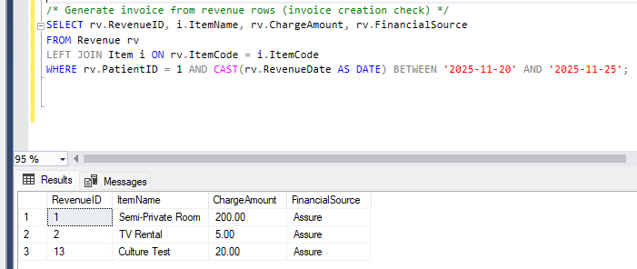

Patient Full Details (personal info, total bookings, total charges, history)
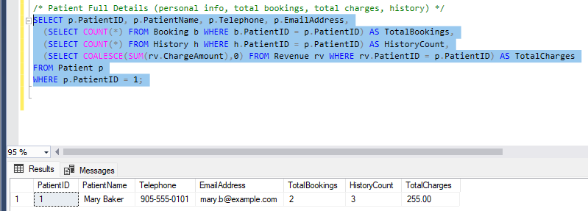

Revenue by Cost Centre (Revenue Analysis)
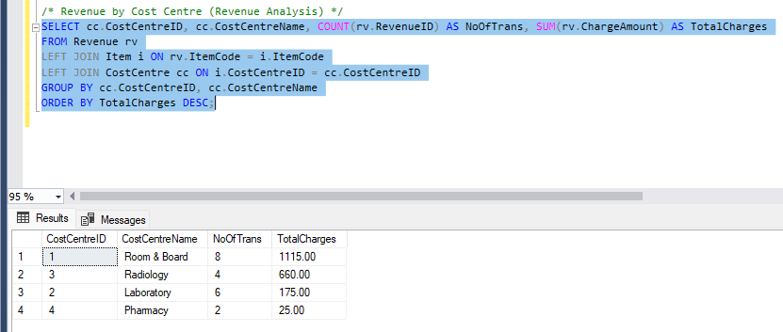

Overall Occupancy by Rooms
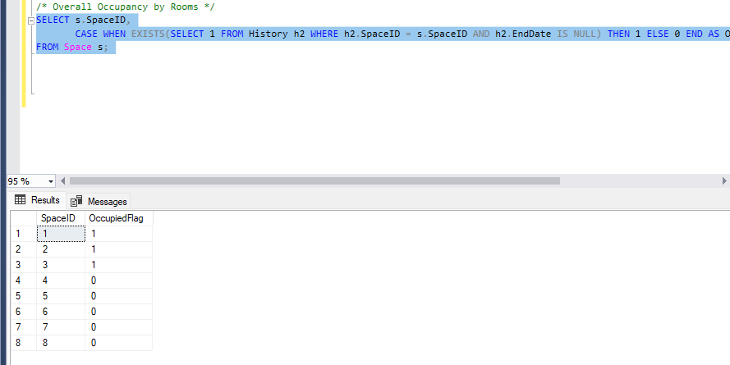
Room Utilization (Show rooms with current patient count and current patient names.)
